Food Delivery App Project in AWS

👤 USER (Browser)
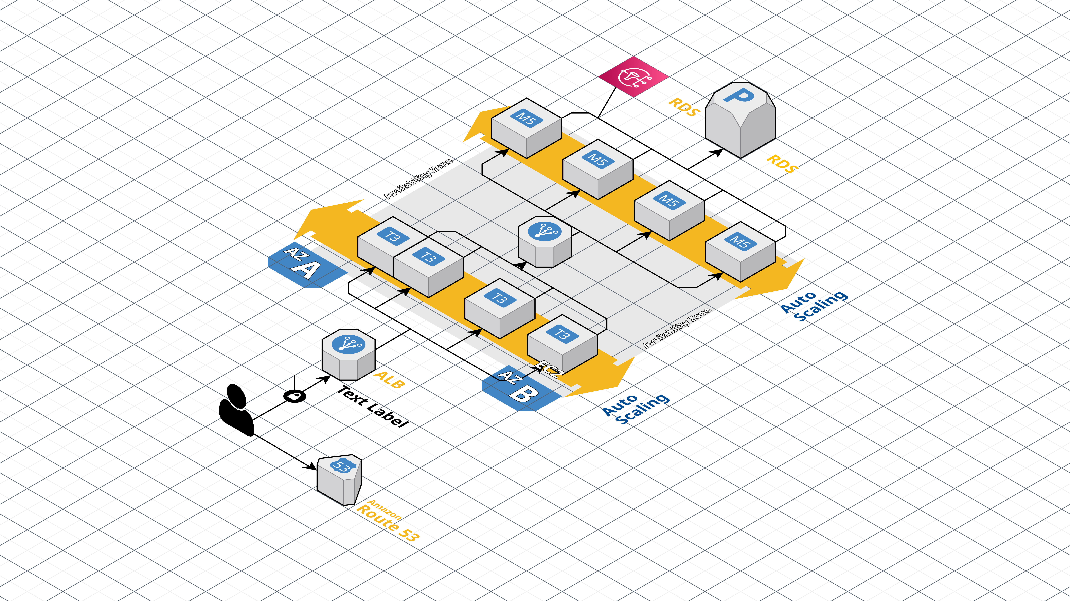
https://app.cloudcraft.co/view/296190c8-89dc-4985-b213-37be85e770da?key=70b9de31-dc87-4ba3-8b67-25dccc9cbac1
Food Order App on AWS: Architecture and Implementation Guide
It provides a comprehensive overview of the Food Order App deployed on AWS, aligning with the provided three-tier architecture featuring ALB, Auto Scaling Group (ASG) with EC2 instances, and RDS MySQL. It reconciles the diagram's scalable public-facing setup with the secure two-tier implementation (public frontend proxy EC2 and private backend EC2), while suggesting enhancements for production scalability. The app enables users to place food orders via a simple web interface, storing data securely in RDS
Architecture Overview
The architecture follows a secure, scalable three-tier model on AWS VPC with public subnet (10.0.1.0/24) for internet-facing components and private subnet (10.0.2.0/24) for the database. Traffic enters through an Application Load Balancer (ALB) in the public subnet, distributing requests to an Auto Scaling Group (ASG) of EC2 instances also in the public subnet running Apache and application code from GitHub. These instances handle frontend serving and proxy requests to backend logic, which connects exclusively to a Multi-AZ RDS MySQL instance with no public access—secured via security groups allowing only EC2 inbound on port 3306.^{[1]}
In the implemented version, the ASG EC2 instances serve a static HTML frontend (served via Apache from /var/www/html/index.html) and a Flask proxy (proxy.py on port 5000) that forwards API calls to a private backend EC2 instance. The backend (app.py) uses Flask and PyMySQL to manage orders in the 'santhos' table of the 'mayilvaganan' database. This design ensures high availability via ASG/ALB scaling and Multi-AZ RDS failover, while maintaining security through subnet isolation and SG rules.^{[1]}
Key Benefits:
- Scalability: ALB + ASG auto-scales web/app servers based on load.
- Security: RDS private-only; EC2 SGs restrict access.
- Reliability: Multi-AZ RDS; code from GitHub for easy updates.^{[1]}
Frontend Explanation
The frontend is a single-page HTML application (index.html) served by Apache on public EC2 instances in the ASG (public subnet 10.0.1.0/24). Users access it via the ALB DNS, entering their name and food item in a centered form with green styling and instant feedback. On submit, JavaScript uses Fetch API to POST JSON to /api/order on the same EC2 (port 5000), handled by the Flask proxy.^{[1]}
The proxy.py script receives the request, forwards it to the private backend EC2's app.py (e.g., http://10.0.x.x:5000/api/order), and relays the response (e.g., "Order received from [user] for [item]"). This cloud-native approach leverages EC2 for static hosting, with ALB enabling HTTPS termination and sticky sessions for scalability. No separate frontend server is needed; Apache pulls code from GitHub on boot via user data scripts.
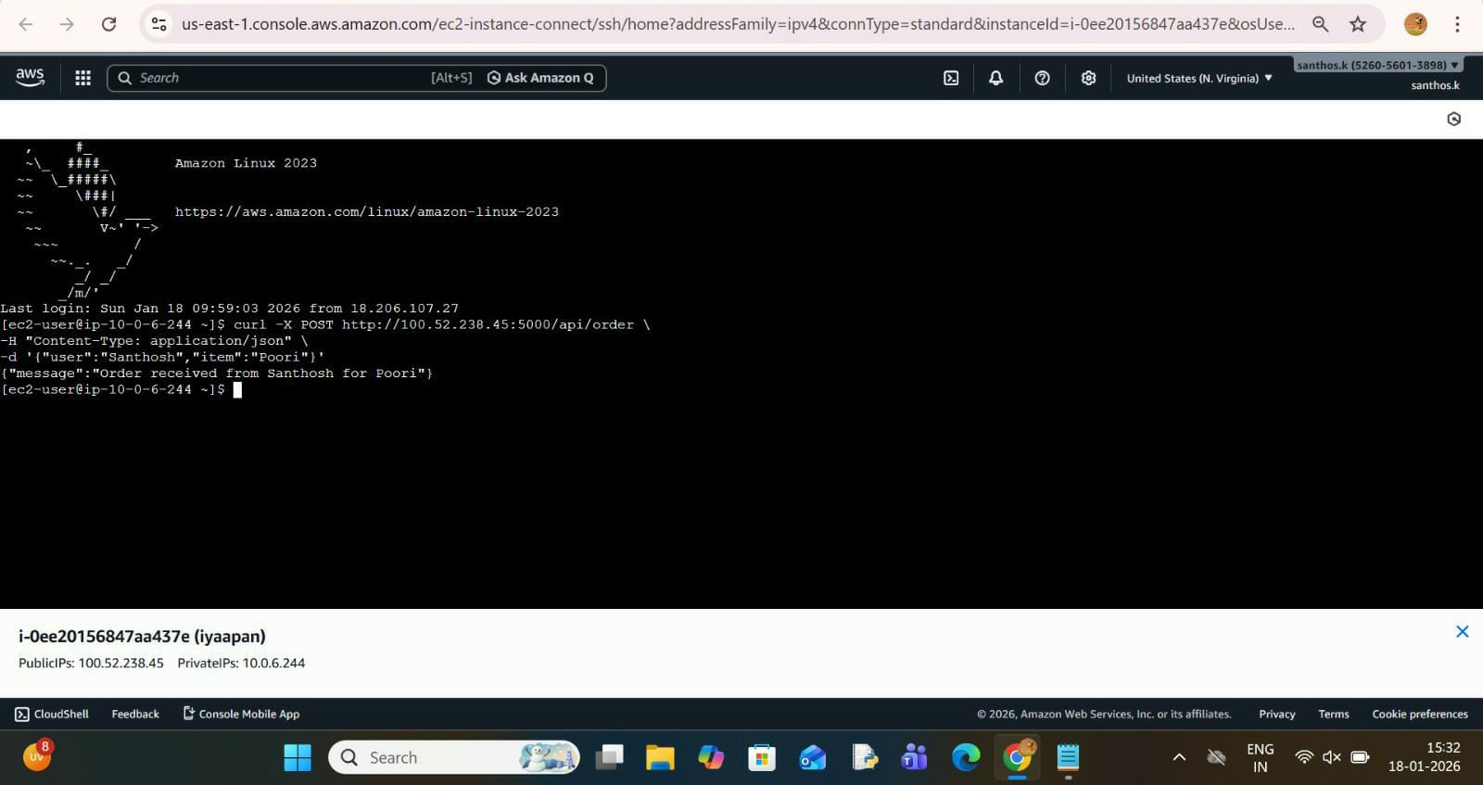

Backend Explanation
Backend logic runs on private EC2 instances (or integrated into ASG EC2 with internal endpoints for production), using Flask (app.py) connected to RDS MySQL. POST /api/orders inserts username/item into the 'santhos' table (id AUTO_INCREMENT PRIMARY KEY, username VARCHAR(50), item VARCHAR(100)). GET /api/orders retrieves all orders as JSON.^{[1]}
In the cloud setup, the public EC2 proxy ensures the backend remains private, preventing direct internet exposure. PyMySQL connects using RDS endpoint (e.g., database-1.c...rds.amazonaws.com), admin user, and secure password. For the diagram's ASG, backend code deploys via GitHub pull on EC2 launch, with Apache proxying or systemd running Flask/Gunicorn for production.
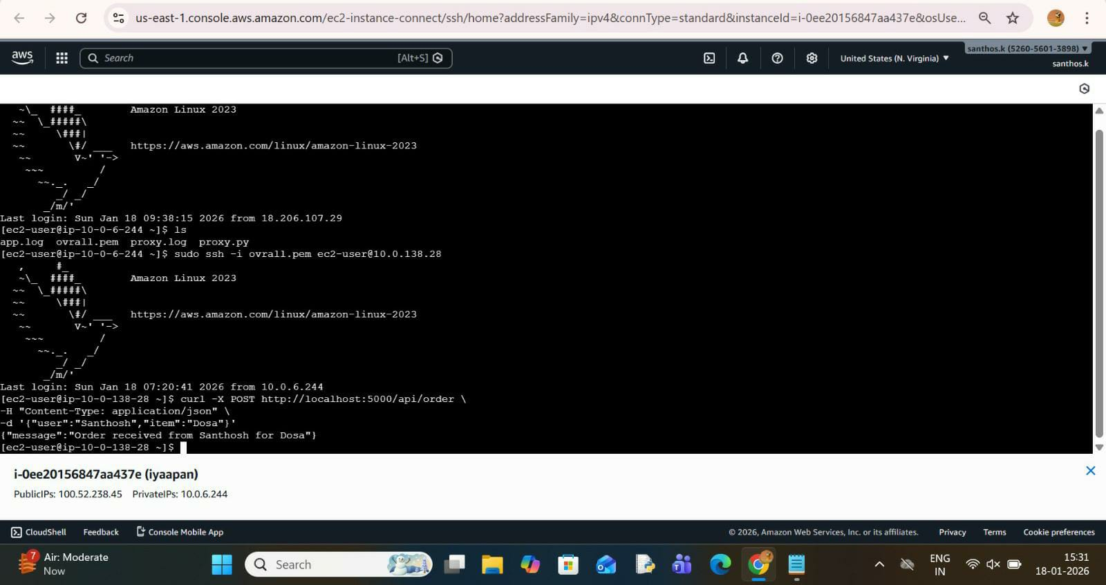
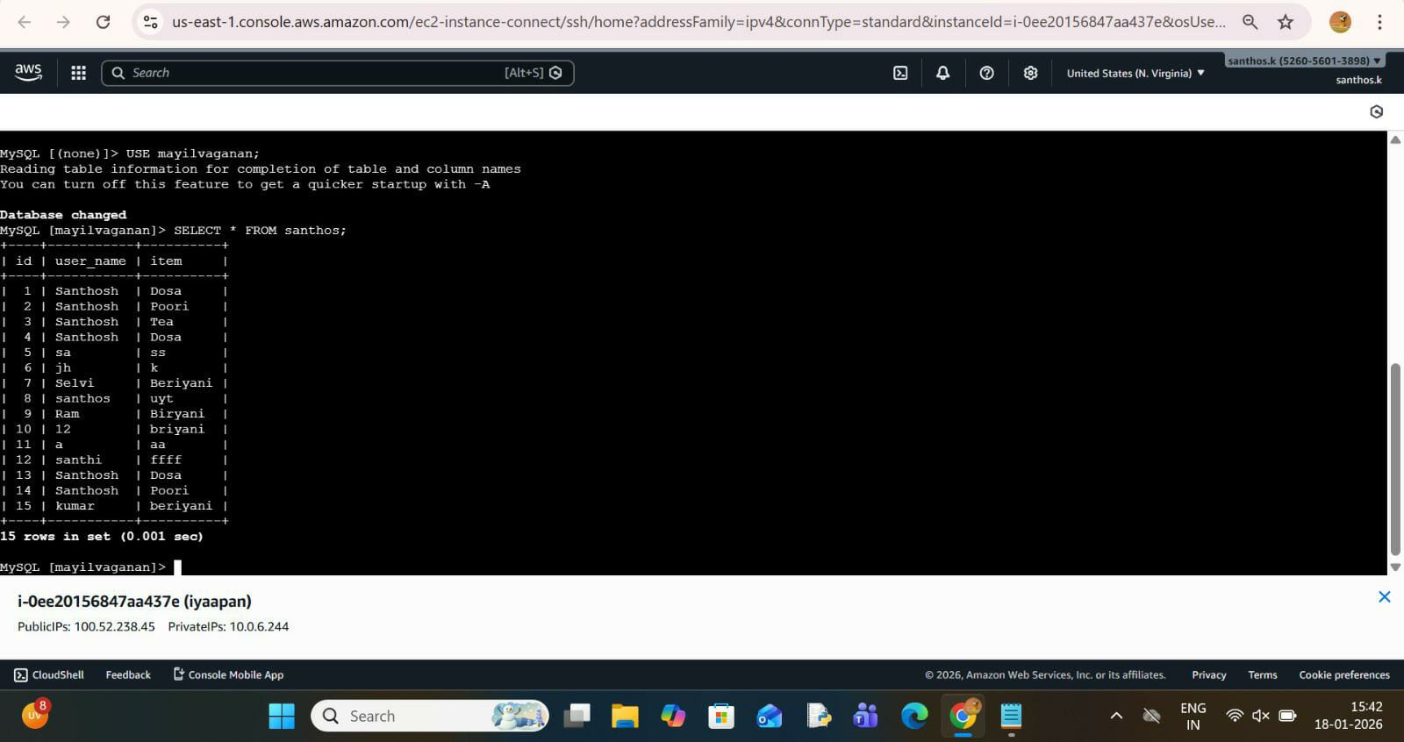

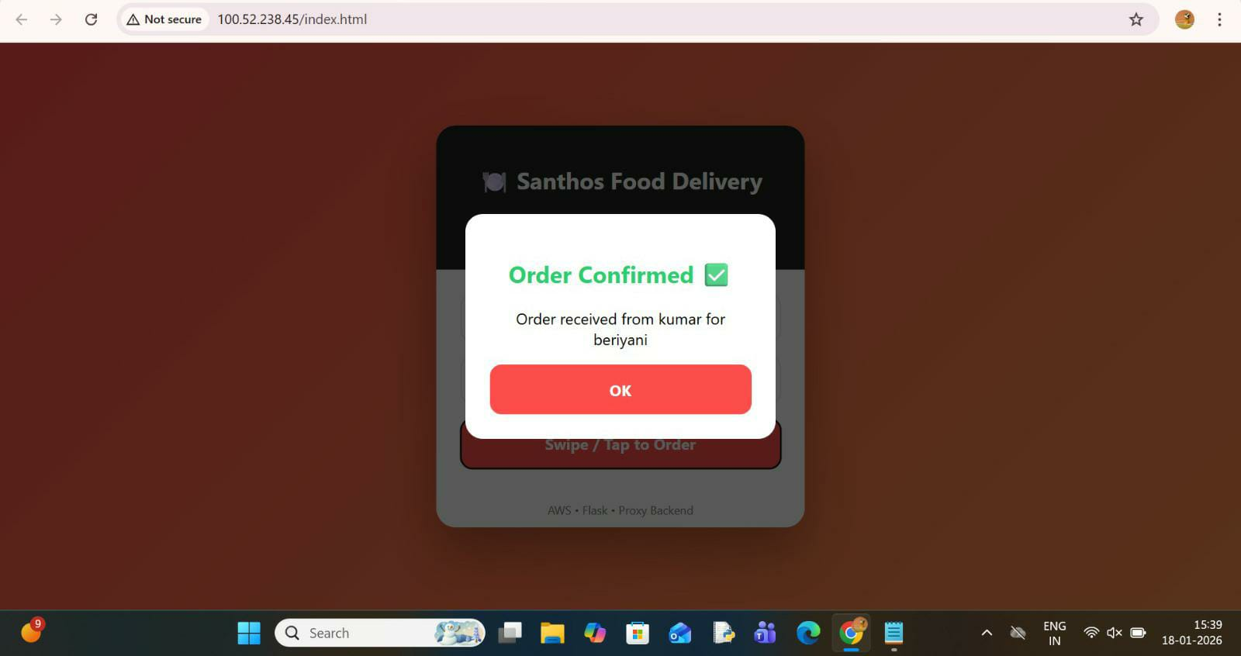

Data Flow:
- Browser → ALB → ASG EC2 (Apache serves HTML + Flask proxy) → Private backend →RDS Responses reverse the path, with CORS enabled for browser safety.
Deployment Alignment with Diagram
To match the diagram exactly:
- ALB: Listens on 80/443, targets ASG on port 80/5000.
- ASG EC2 (public subnet): User data script installs Apache, clones GitHub repo, serves index.html, runs proxy.py (or full backend if single-tier).
- RDS: Multi-AZ, private subnet, SG allows 3306 from EC2 SG only.
Enhance with Route 53 for custom domain, CloudWatch alarms for ASG scaling, and Secrets Manager for DB credentials.

SNS Topic Setup
Create an SNS topic named "FoodOrderNotifications" in the AWS console (same region as your VPC). Standard topics support fanout to multiple subscribers, with FIFO topics available for ordered delivery if needed. Enable topic encryption using AWS KMS for compliance, and set access policy to allow publishing only from your EC2 backend IAM role.
